What Happened to the People in Microsoft's Iconic 1978 Company Photo
  - It's one of the most iconic photos in American business. It's one of the most iconic photos in American business. But whatever happened to Microsoft's first 11 employees? We found out.
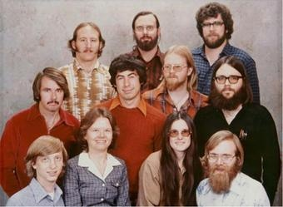
A ragtag group of bearded weirdoes assembled for a family portrait in Albuquerque. Usually, there's a question above the photo: "Would you have invested?"
It's a trick question. You're supposed to answer no – because well, look at those people – but then you learn it's a company portrait of Microsoft from 1978.
It was taken just before the then startup left Albuquerque for Seattle. (Microsoft couldn't find anyone willing to move to New Mexico.)
Early employee Bob Greenberg, pictured in the middle, won the free portrait after calling in a radio show and guessing the name of an assassinated president. The gang reluctantly gathered together in some of their finest attire, and American business legend was made.
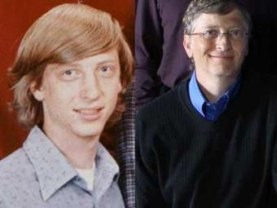
We all know what happened with the two guys in the bottom left and bottom right corners — Bill Gates, and Paul Allen. But what about the rest? We saw the question pop up on Hacker News recently, and decided to find out.
Bill Gates is now giving away the billions he made from Microsoft
We all know what happened with this guy. Bill Gates founded and built Microsoft from nothing into the most valuable technology company in the world. Along the way he amassed a fortune, which he's now giving away to all sorts of good causes.
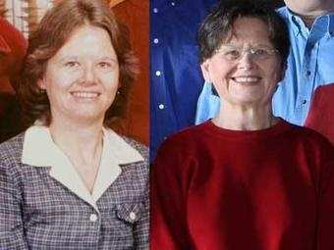
Andrea Lewis became a fiction writer and freelance journalist
Andrea Lewis was the only person at the company that was from Albuquerque. She was a technical writer for Microsoft, which meant she wrote documents explaining Microsoft's software. She left Microsoft in 1983, eventually becoming a freelance journalist and fiction writer. Thanks in part to her Microsoft options, her net worth was estimated at $2 million back in 2004 by the AP.

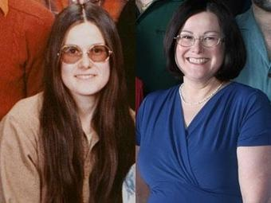
Maria Wood sued Microsoft just 2 years later
Maria Wood was a book keeper for Microsoft, and married to another one of the early Microsofties in the picture. She left the company just two years later, suing it for sexual discrimination. Microsoft settled the case. After that, it doesn't look like she did much else. She raised her children and became a volunteer.
Paul Allen has spent his billions on sports teams, startups, and much more
After Bill Gates, Paul Allen is the most famous guy in the group. Allen, the other Microsoft cofounder, is the 37th richest person in the world according to Forbes. He's the owner of the Portland Trailblazers, the Seattle Seahawks. He also owns one of the biggest yachts in the world, and much more
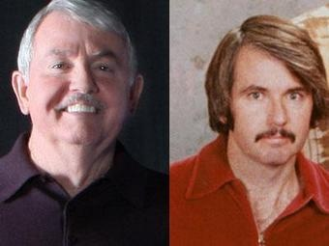
Bob O'Rear went onto be a cattle rancher
Bob O'Rear was one of the oldest employees at Microsoft. He was at NASA in Mission Control when we landed on the moon. At Microsoft he was a chief mathematician, and is credited with reworking code in DOS, and getting it onto IBM PCs. He left the company in 1983, moved back to his home state of Texas, and did some cattle ranching. His worth is estimated at $100 million, and he sits on the board of a few local businesses.
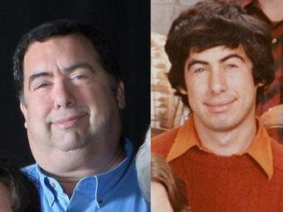
Bob Greenberg left Microsoft, then worked on the Cabbage Patch Kids
Bob Greenberg was the guy that won a radio call-in contest to get the photo. He left Microsoft in 1981, after helping the company develop a new version of BASIC. When he left he went on to help his family's company, Coleco, develop the Cabbage Patch Kid dolls, which became a huge hit. More recently, he's said to have worked on golf course software.
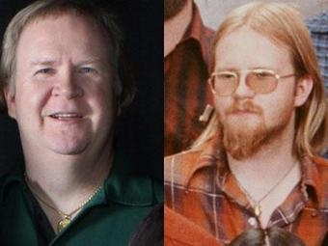
Marc McDonald left Microsoft because it was getting big, but ended up back at the company, anyway
Marc McDonald was the first salaried employee, and when he left in 1984, it was because he didn't like how big the company was getting. After leaving Microsoft he went to another Paul Allen company, Asymetrix. He then went to Seattle design company Design Intelligence, which was acquired by Microsoft in 2000. So, he ended up back at Microsoft! According to the AP, he said he has said he is worth less than $1 million.
Gordon Letwin stayed with Microsoft longer than anyone other than Bill Gates
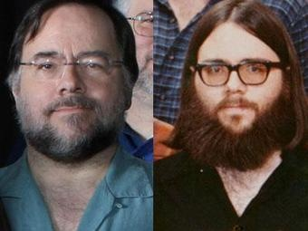
Gordon Letwin was with the company until 1993, the second longest run of all the employees pictured (Gates is first). He was a programmer at Microsoft, and quit when he wanted a break from the grind of the company. He has a ranch in Arizona, and has donated money to some environmental causes. His worth is estimate at $20 million or so.

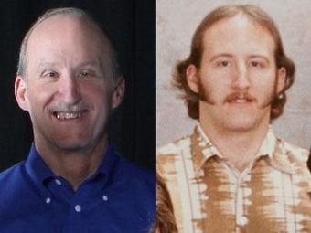
Steve Wood went on to found Wireless Services Corp.
Steve Wood is the husband of Maria Wood, who eventually left Microsoft under bad circumstances. Steve left in 1980, but worked with Paul Allen on a few companies. He founded Wireless Services Corp., a mobile messaging company, in 1996. It's been renamed SinglePoint, and he's now the chairman. He and his wife's net worth is pegged at $15 million now.
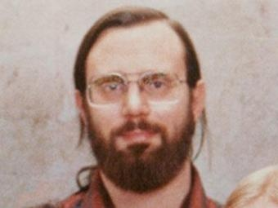
Bob Wallace was a fan of psychedelic drugs and founded a software company after Microsoft
Bob Wallace seems like he was one of the most far out early Microsoft employees. He spent time and money researching psychedelic drugs after leaving the company. He also founded a software company called Quicksoft. He died in 2002 from pneumonia.

Jim Lane went on to do his own software company
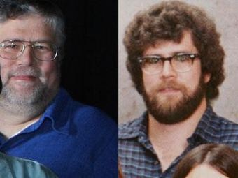
Jim Lane was a project manager who left in 1985 reportedly saying, Microsoft "beat the enthusiasm out of me." He went on to start his own software company. At Microsoft he helped with the early partnership with Intel. (Something that's been pretty useful for Microsoft so far.)

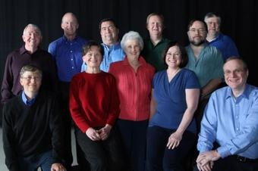
Here's one more look at the gang from 1978 ...
... And here's a photo of them from 2008 that Microsoft put together when Bill Gates was leaving the company (Yarow)

Bibliography
Yarow, Jay. Gizmodo. 27 January 2011. 27 January 2011 <http://gizmodo.com/5743900/where-are-they-now-what-happened-to-the-people-in-microsofts-iconic-1978-company-photo>.

