How to create a student Gmetrix account for Microsoft Office practice?
- Students go to the web address - http://www.gmetrix.net/Login.aspx
- Next, student creates a new profile account.
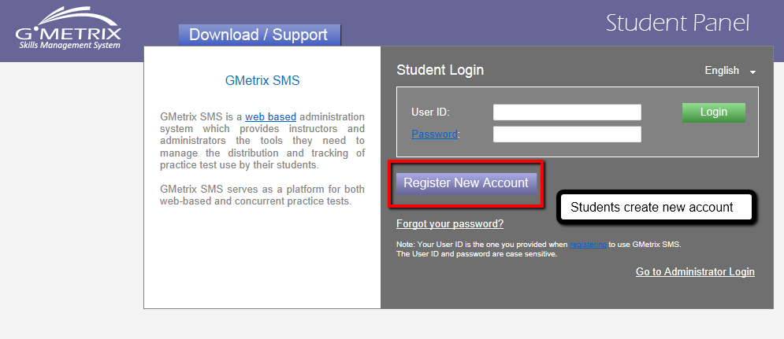

- Complete all required information. See next image for more details.
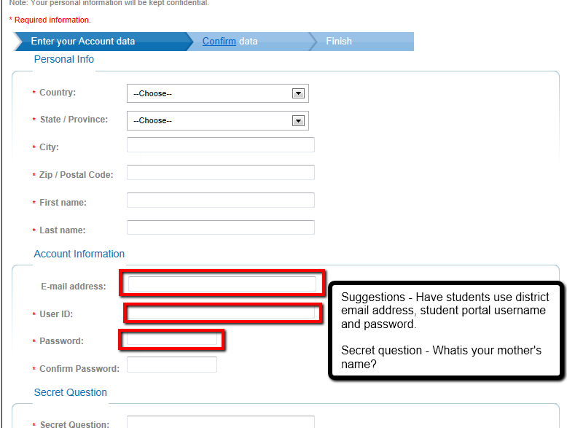
- Complete registration and close web browser.
- Students click on the Gmetrix icon on the desktop.
- Students sign in with the username and password they created.
- Students use the group access code the teacher will give them.
- Students complete assignments.

Students working at Home

- Sign into www.gmetrix.net
- Download the application on to home computer
- Log in with the access code the teacher has given you.

