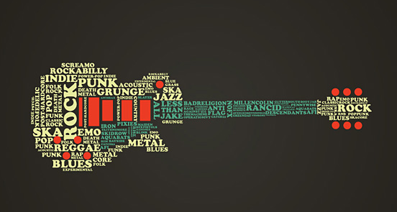

Guitar II
Teacher: Mr. Mastrovito
NMastrovito@dadeschools.net
Year: 2016-2017

Course Description
This course is designed for the intermediate guitar student. The class is taught in a
group setting. Some prior guitar experience required. Time outside of class is required
to succeed. The main goal is for student to begin to develop the ability to play the guitar
in a variety of guitar-based music from traditional to contemporary genres. Some of
these genres are classical, jazz, blues, folk, country, and rock.

Course Objectives
- Tune guitar properly.
- Learn how to properly read music (Chords, Music Notation).
- Incorporate lessons about Rhythm, Melody, Harmony, Tempo, and Dynamics.
- Perform music using proper technique (posture, hand position, etc).
- Perform music in small groups (ensembles) for the rest of the class.

Expectations
- Each student is to bring the materials listed below everyday.
- Guitars will be handed out during class and careful handling is required.
- Students are expected to participate and be supportive of the rest of the class.

Materials Needed
- 3-prong duo tang folder for handouts and music
- Picks (optional)
- Pencil
- One time class fee of $20

Grading
25%: Performances
25%: Assignments
25%: Attendance
15%: Concert Performance
10%: Homework (practice)

Points will be deducted for: Unexcused absence, excessive talking, tardiness, forgetting materials for class.

I HAVE READ THE GUITAR SYLLABUS IN ITS ENTIRETY. I UNDERSTAND IT AND AGREE TO FOLLOW THESE EXPECTATIONS AS WELL AS THE EXPECTATIONS ESTABLISHED IN THE MIAMI BEACH SENIOR HIGH HANDBOOK.
Please sign below to show that you have read the class syllabus and understand its content. Please detach this sheet and turn it into Mr. Mastrovito no later than Friday, Sept 12th, 2016.
Student Name ________________________________
Student Signature _____________________________
Date _________________________
Parent Signature _________________________________
Date _________________________

